Chapter 2

Systematic Analysis of non-verbal cue requirements and design of the Social Interaction Assistant

From Research Question 1, it is certain that there is no analysis on the needs of the visually impaired and the blind community about their needs during social interactions. Though research supports the need for social interactions, no efforts have been taken towards determining the specific necessities that this community has. In order to identify the unmet needs of the visually impaired community, two focus groups consisting primarily of people who are blind, as well as disability specialists and parents of students with visual impairment and blindness where conducted[1]. Members of these focus groups who were blind or visually impaired were encouraged to speak freely about their challenges in coping with daily living. During these focus groups, the participants agreed on many issues as being important problems. However, one particular problem - that of engaging freely with their sighted counterparts - was highlighted as a particularly important problem that was not being addressed by technology specialists[2].

As an example of the type of social disconnect that people who are visually impaired face, consider a simple form of nonverbal communication: glancing at a watch to signal that it is time to wrap up a meeting. The sighted participants might respond to such a glance automatically, without consciously realizing that this visual information is not accessible to a participant who is blind. Similarly, a sighted person asking a question in a group will use gaze direction and eye contact to indicate to whom the question is directed. Without access to this visual cue, people who are blind might be left wondering whether the question was directed to-wards them. They can answer immediately (at the risk of feeling foolish if the question was not directed at them) or they can wait to see if anyone else answers (and risk being thought of as rather slow witted).

While various other examples were cited by individuals during these focus group studies, the inability to access non-verbal cues were considered of highest priority. In this chapter, we introduce a self-report survey that was conducted based on the focus group study results that highlight the various non-verbal cues that are considered important from the perspective of the user population. Further, with the non-verbal cue priority list determine, the design of a platform that can be used for extracting and delivering these non-verbal cues is presented.

# 2. 1 Requirements for a Social Interaction Assistant

Based on the discussions conducted through the two focus groups, a list of needs was complied that characterized social needs often experienced by people with visual impairments. In doing so, two important aspects of social interaction were identified. These included

1. Access to the non-verbal cues of others during social interactions, and
2. How one is perceived by others during social interactions.

These needs correlated with the psychology studies conducted by Jindal-Snape with children who were visually impaired. She identifies these two needs under the *Social Learning* and *Social Feedback*. As discussed in Chapter XXX, Section XXX, these are the two important aspects of providing assistance and rehabilitation for people who are blind and visually impaired. While these two important categories were identified, for simplicity, the non-verbal cue needs were reduced to 8 aspects of social interactions that focused primarily on the physical characteristics of the interaction partner and the behaviors of the interaction partner. These questions were developed with the help of visually impaired professionals and students:

1. Knowing how many people are standing in front you, and where each person is standing.

2. Knowing where a person is directing his/her attention.

3. Knowing the identities of the people standing in front of you.

4. Knowing something about the appearance of the people standing in front of you.

5. Knowing whether the physical appearance of a person who you know has changed since the last time you encountered him/her.

6. Knowing the facial expressions of the person standing in front of you.

7. Knowing the hand gestures and body motions of the person standing in front of you.

8. Knowing whether your personal mannerisms do not ﬁt the behavioral norms and expectations of the sighted people with whom you will be interacting.

While these 8 aspects of social interaction were important from the perspective of enriching social interactions of the people who are blind or visually impaired, it was not sufficient to just identify them, but it is important to determine the relative importance of these needs with respect to each other. To this end, an online survey was carried out to determine a self-report importance map of the various non-verbal cues. This list of questions included both the importance from the perspective of allowing access to the non-verbal cues of the interaction partner (for enabling Social Learning), while also focusing on the personal body mannerism (for enabling Social Feedback) of the individual.

# 2.2 Online Survey

The online survey was anonymously completed by 28 people, of whom 16 were blind, 9 had low vision, and 3 were sighted specialists in the area of visual impairment and vocational training. The online survey consisted of eight questions that corresponded to the previously identiﬁed list of needs. Respondents answered each question using a ﬁve-point Likert scale, the metrics being

(1) Strongly disagree,

(2) Disagree,

(3) Neutral,

(4) Agree, and

(5) Strongly agree

The survey can be analyzed as having 3 groups (individuals who are blind, individuals with visual impairment and specialists with 20/20 vision) and 8 question groups each corresponding to the 8 aspects of social interactions that were identified from our focus group.

# 2.3 Results:

## 2.3.1 Mean Score Table:

Table 1 shows the eight aspects of social interactions, sorted by descending importance, as indicated by the survey respondents (the question numbers correspond to the need listed in the previous section). The mean score is the average of the respondents on the 5 point scale that was used to capture the opinions. A score closer to 5 implies that the respondents strongly agree with a certain question and that they consider inaccessibility to that particular non-verbal cue to be important deterrent to their social interactions. On the other hand, a score closer to 1 represents the respondent did not consider the access to a specific non-verbal cue to be important during their social interactions.

|  |  |  |
| --- | --- | --- |
| **Need** | **The Question** | **Mean Score** |
| 8. | I would like to know if any of my personal mannerisms might interfere with my social interactions with others. | 4.5 |
| 6. | I would like to know what facial expressions others are displaying while I am interacting with them. | 4.4 |
| 3. | When I am standing in a group of people, I would like to know the names of the people around me. | 4.3 |
| 7. | I would like to know what gestures or other body motions people are using while I am interacting with them. | 4.2 |
| 1. | When I am standing in a group of people, I would like to know how many people there are, and where each person is. | 4.1 |
| 2. | When I am standing in a group of people, I would like to know which way each person is facing, and which way they are looking. | 4.0 |
| 5. | I would like to know if the appearance of others has changed (such as the addition of glasses or a new hair-do) since I last saw them. | 3.5 |
| 4. | When I am communicating with other people, I would like to know what others look like. | 3.4 |

Table 1: Results of the online survey

## 2.3.2 Histogram of Responses:

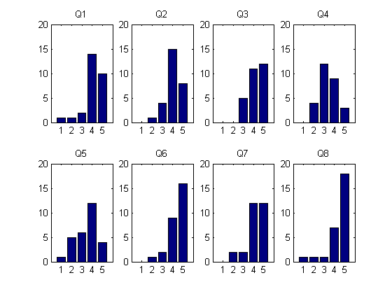

Figure 2: Histogram of Responses grouped by Questions

Figure 2 shows the histogram of responses for the 8 Questions that were asked as part of the survey. Each subplot refers to a single question and shows the number of times users responded to that particular question with answers from 1 to 5 on the Lickert Scale. Each histogram adds up to a total of 28 that corresponds to the 28 participants that took part in the online survey.

## 2.3.3 Box Plot Analysis:

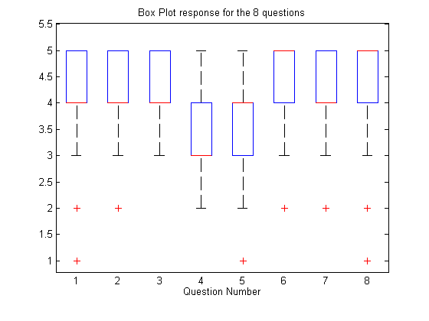

Figure 3: Box Plot of user responses for the 8 questions on the survey

The Box Plot of the 8 question responses is shown in Figure 3. The median values of the responses are shown as red lines for each of the 8 questions. While the blue box shows the enclosure for all responses between the 75 percentile and the 25 percentile points. Since the responses were on an integer scale of 1 through 5, the median coincides with the upper or lower 25 percentile. The whisker corresponds to the upper and lower limit of the values represented under that particular question. The plus marks represent any outliers under each question. Outliers are indentified based on whether they are outside the 3 sigma (variance) from the mean value. Note that the median value for questions 6 and 8 are at 5, median value of 4 for questions 1, 2, 3, 5 and 7, and median of 3 for question 4. Historically, Licket Scale data has been analyzed using Box Plot analysis as the plot captures all the descriptive statistics of minimum value, maximum value, median, variance, and the inter quartile range that encapsulates the 50 percentile of the data around the mean.

## 2.3.4 Response Ratio:

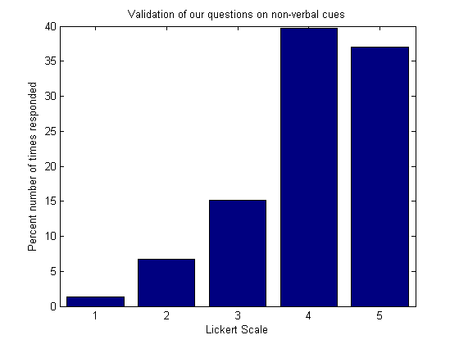

Figure 4: Response Ratio

Figure 4 shows the number of times the respondents chose to answer the 8 questions with their agreement or disagreement. The y-axis has been normalized to 100 points. The graph shows that respondents chose to answer the most by agreeing (Likert Scale 4) with the 8 questions. Followed closely behind was the strong agreement (Likert Scale 5) with the questions asked in the survey. The respondents chose to answer the least through strong disagreement (Likert Scale 1) to what was asked in the survey.

## 2.3.5 Rank Average and F-score:

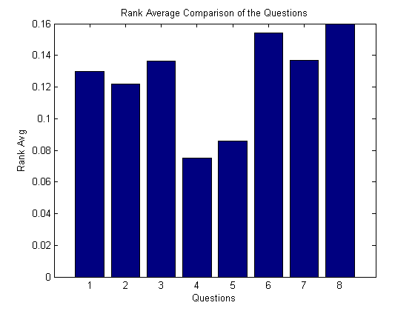

Figure 5: Rank Average of responses for the 8 questions asked in the online survey.

As can be seen from Figure 4, the questionnaires were biased and the frequency of the responses is not Gaussian. This bias implies that using sample mean of the Lickert Scale responses will immediately show the same bias. This is due to the Gaussian iid assumption that is made while extracting the mean for the answers. In order to overcome this non-Gaussianity, we resort to non-parametric mean for the responses. Rank average of the responses is estimated instead of the typical mean of the responses for each of the question. The procedure for estimation of the rank average is shown below:

1. Rank all data from all groups (question) together; i.e., rank the data from 1 to *N* ignoring group membership. Assign any tied values the average of the ranks they would have received had they not been tied. Let this rank be referred to as , where *i* represents the group (question) and *j* represents the individual element.
2. Rank Average for each group is then given as



Where,

is the average rank of the group (question) with the cardinality .

Further,

Since no assumptions on the distribution of the response are made, unlike the mean, the rank average gives a non-parametric method for comparing the responses of the individuals. The ranks can be either assigned ascending or descending with respect to the responses, i.e. rank 1 could mean all responses that were answered with strongly disagree (numeral 1), or rank 1 could mean all responses that were answered with strongly agree (numeral 5). In the Figure 5, we have assigned rank 1 to strongly disagree. This is for the sake of visual convenience. Thus, higher the average rank, higher is that group’s response from the respondents. Comparing Figure 5 to Table 1, it can be seen that the same ordering of priority can be seen through mean and rank average. But the mean tends to show very little variation between responses due to the bias that is present in the questions. On the other hand the rank average provides a good comparison scale.

## 2.3.6 Average Response per Group:

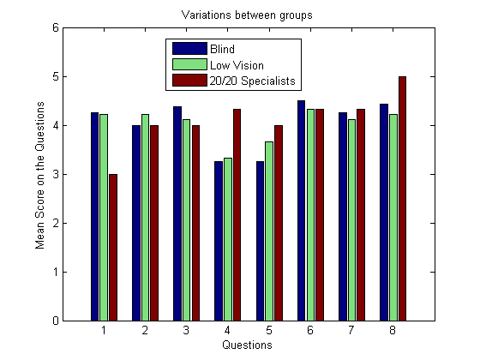

Figure 6: Average responses of the 3 user groups (Low Vision, Blind and 20/20 Specialists)

Figure 6 shows the average responses for each question based on the group to which they belong. Based on whether the respondents belong to blindness, low vision or the sighted specialists group, the average of all the responses is plotted. In most of the questions, all three groups seem to be responding similarly, but in question 1 and 4 there is a significant deviation of the sighted respondent from the visually impaired respondents.

# 2.4 Analysis of the survey responses

## 2.4.1 Histogram of the responses:

A histogram of responses is shown in Figure 1. From the average score of the participants who took the online survey, it can be seen that,

1. Respondents are highly concerned about how their body mannerisms are perceived by their sighted peers (based on the response to Question 8 on the survey).
2. Facial expressions form the most important visual non-verbal cue that individuals who are blind or visually impaired feel they do not have access to (based on Question 6 on the survey). This correlates with the studies into non-verbal communication that highlights the importance of facial mannerisms and gestures, which are mostly visual in their decoding.
3. Followed by facial expressions, body mannerisms seem to be of higher importance for individuals who are blind and visually impaired (based on Question 3 of the survey). This can be correlated to the table shown Chapter XXX, Section XXX, where body follows the face in terms of displaying non-verbal cues.
4. The responses to questions 7, 1 and 2 suggest that respondents would like to know the identities of the people with whom they are communicating, relative location of these people and whether their attentions are focused on the respondent. This corresponds to knowing the position of their interaction partners when they are involved in a bilateral or group communication. People tend to move around, especially when they are standing, causing people who are blind to lose their bearing on where people were standing. This can result in individuals addressing an empty space assuming that someone was standing there based on their memory.
5. The responses to questions 4 and 5 indicate that there was a wide variation in respondents’ interest in (4) knowing the physical appearance of people with whom they are communicating and (5) knowing about changes in the physical appearance of people with whom they are communicating. Many respondents indicated moderate, little, or no interest in either of these areas.

## 2.4.2 Box Plot Analysis:

The Box Plot analysis reiterates the fact that Question 8 and 6 carries the highest response, with the respondents wanting to know their own body mannerism and how it was affecting the social interactions. This was immediately followed by the facial expressions of the interaction partners. Thus, self assessment in social interactions was of prime importance to these individuals.

## 2.4.3 Response Ration - Questionnaire Bias:

As described earlier, the 8 questions corresponding to the social needs of the individuals were identified from the focus group survey that was conducted. Thus, the questions presented in the online survey questions were biased towards the needs of everyday social interactions of individuals who are blind and visually impaired. Thus, the implicit assumption while preparing this survey itself is that most of these items have been identified as being important and that only a priority scale needs to be extracted. This implicit assumption is immediately brought out by looking at the frequency with which the respondents answer with their agreement (Likert Scale 4) and strong agreement (Likert Scale 5).

## 2.4.4 Rank Average Response:

Taking into account the bias that is present in the questionnaire, the rank average response for all the 8 questions indicate that the inferences that are derived from the mean analysis in Table1 and the box plot analysis in Figure 3 are consistent and that individuals who are blind and visually impaired do consider that own body mannerism to be of utmost importance when they are involved in a social interaction. Further, facial expressions follow their egocentric body behavior as being the next most important aspect of their social interactions. The rank average correlates with mean analysis even after the questionnaire bias is removed.

## 2.4.5 Average Response per Group:

Finally, from Figure 6 it is seen that there is some response difference between the visually impaired (including blind) population and the sighted specialist population that were presented with the same set of questions. Though the results between populations seem consistent, for question 1and question 4, there seems to be disagreement between the sighted and the visually impaired populations. This could be because of the smaller sample size of sighted specialists that took the survey and could purely be due to outliers. Further investigation is needed into this issue.

# 2.5 Summary:

In this study we generate a prioritized list of social cues that are considered important by people who are blind and visually impaired. Created from two focus group studies of blind and visually impaired individuals, the list of social cues are then assessed through a self-reported ranking scheme that provides the much needed prioritized social needs list.

It can be seen from this list that the people who are visually impaired and blind consider their own personal body mannerisms to be of highest importance when they are involved in social interactions. Any feedback that can be given to them about their body mannerisms will aid in their social learning. Followed closely behind their own mannerisms, the facial expressions of their interaction partners seem to be of highest importance when it comes to visual non-verbal cues.

Following this discussion of the various social needs of individuals who are blind and visually impaired, the Social Interaction Assistant platform itself is introduced below.

# 2.6 Alternative Sensing Platforms for a Social Interaction Assistant

Having determined the requirements for a Social Interaction Assistant, a potential platform for the Social Interaction Assistant is considered next. In Section XXX of Chapter XXX, we discussed some of the important observations we have made on the needs for an social interaction assistive technology. The needs are listed here again for clarity.

A device that is developed to facilitate the social interactions of people with sensory, or cognitive disabilities might do so by (1) detecting social cues during social interactions and delivering that information to the user in real time to enable them to engage in social interactions, or (2) detecting the user’s stereotypic behaviors during social interactions and communicating that information to the user in real time to provide social feedback. The first device might be classified as an assistive technology, while the second might be classified as a rehabilitative technology. Ideally, such a device would be based on the following design principles:

*Design principle 1:* The device should be portable and wearable so that it can be used in any social situation, and without any restriction on the user’s everyday life.

*Design principle 2:* The device should employ sensors and personal signaling devices that are unobtrusive, and do not become a social distraction.

*Design principle 3:* The device should include sensors that can detect the social mannerisms of both the user and other people with whom the user might communicate.

*Design principle 4:* The device should be comfortable enough to be worn repeatedly for extended periods of time, to allow it to be used effectively for rehabilitation.

*Design principle 5:* The device should be able to reliably distinguish between the user’s problematic stereotypic mannerisms and normal functional movements, to ensure that it will be worn long enough to achieve rehabilitation.

## 2.6.1 Concept Social Interaction Assistant Prototypes:

### 2.6.1.1 Concept 1:

A wearable video camera in a clip-on device, and a small audio emitter device that could be worn on the ear without obstructing normal hearing. Both of these devices would be connected to a compact computing element such as an Ultra-mobile PC (UMPC) (Fig. 7).

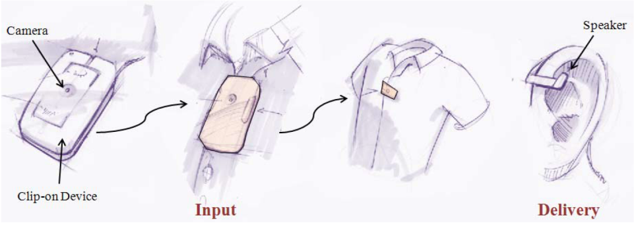

Figure 7: A clip on camera and small speaker

### 2.6.1.2 Concept 2:

A tiny, ear-mounted video camera and sound emitter (inspired by Bluetooth headsets) mounted on a small device that communicates with a UMPC (Fig. 8).

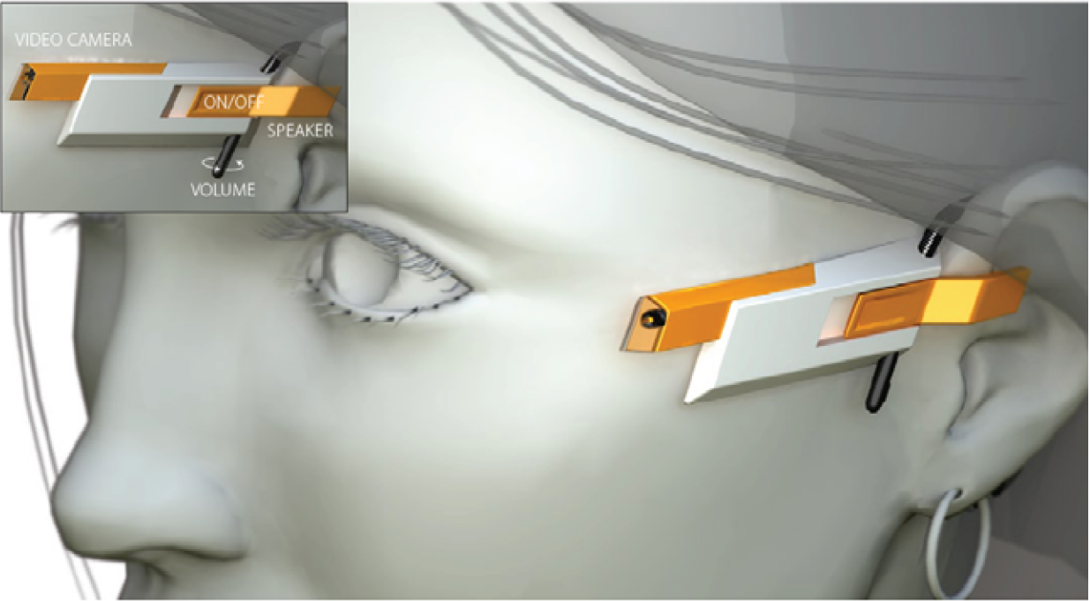

Figure 8: A ear-mounted video camera and speaker

### 2.6.1.3 Concept 3:

A tiny video camera and a sound emitter mounted unobtrusively in a pair of glasses - both of which are attached to a UMPC (Fig. 9).

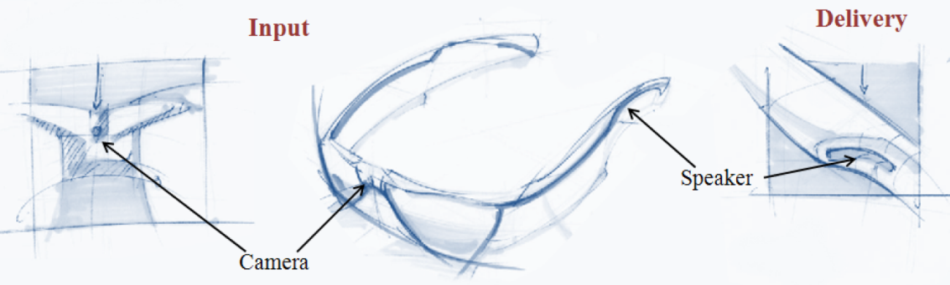

Figure 9: A tiny video camera and speaker on a pair of glasses.

## 2.6.2 Social Interaction Assistant Prototype:

Having analyzed the requirements and considering the various components of the sensing and delivery technology, we resorted to Concept 3 and incorporated the important aspects of egocentric and exocentric sensing into the prototype system.

### 2.6.2.1 System Architecture

The system level architecture of the proposed social interaction assistant is shown in the Figure 10. The sensor suite consists of:

1. A visual sensor (1.4 Megapixel camera),
2. A motion sensor (± 12g accelerometer), and
3. A 5-button clicker, which serves as a user interface.

The social interaction assistant software (implemented on a Windows Operating System PDA) uses these sensors to collect information about the various social and behavioral mannerisms of the user and participants in the vicinity of the user.

Interpretations of the social interactions generated by custom algorithms are communicated to the user through an actuator suite, consisting of:

1. A haptic belt, and
2. A pair of ear phones.

The haptic belt encodes information in the form of vibrotactile cues, while the ear phones provide short audio cues. As future extensions to this project, in Chapter XXX, we introduce the Haptic Glove and a new interface for communicating facial affect.

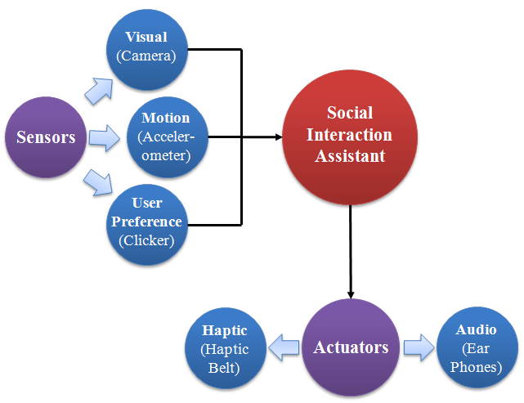

Figure 10: System level architecture of the Social Interaction Assistant

### 2.6.2.2 Prototype System:

Figure 11 shows the implementation of the proposed Social Interaction Assistant. A tiny video camera is placed unobtrusively on a pair of glasses, and a tiny state-of-the-art accelerometer is placed unobtrusively in a hat, and is used to monitor the user’s body mannerisms – particularly those related to head and body movement. (Most communicative gestures are encoded in movements of head and the most widely occurring and problematic stereotypic body mannerisms are done with the head.) The accelerometer operates on a coin battery that allows for uninterrupted operation for over 4 hours. The user uses the 5-button clicker to control what types of information are delivered by the system. The haptic belt can be worn under the clothing, and the earphones are worn discretely under their hat. Thus, the proposed design of the assistive technology is (1) wearable, (2) portable, (3) unobtrusive, (4) self and other sensing, and (5) can be worn by the user for extended periods of time.

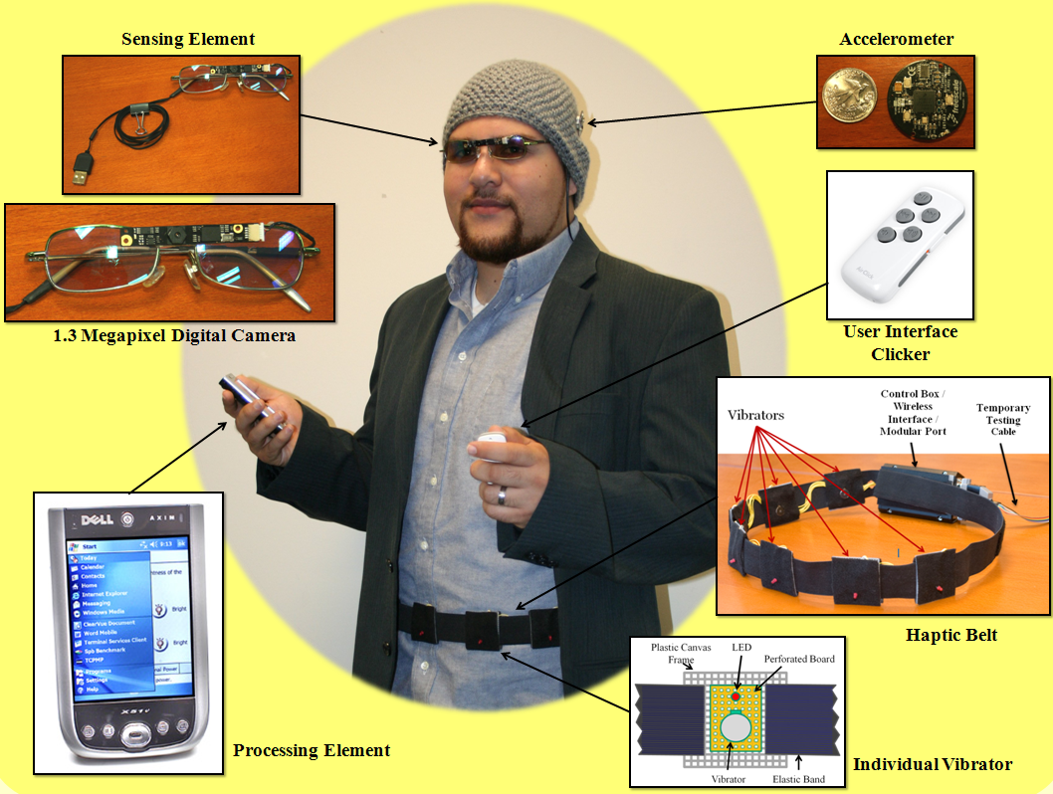

Figure 11: the implementation of the Social Interaction Assistant

## 2.6.3 The Haptic Belt:

While most other components of the Social Interaction Assistant are sensors that are already well explored in the areas of signal processing, pattern recognition and machine learning, the haptic belt as an actuator is novel contribution from the work that was done towards Social Interaction Assistant. The details of the belt are given below for the sake of completeness.

Figure 12 shows the specifics of the implementation. The belt is wireless with 16 vibrotactile actuators that encircle the waist of the user. The wireless connection between the belt and the computer provides the desired portability and limited cumber upon which the rest of the system is developed. The wireless haptic belt consists of a hierarchical microcontroller design with a main controller (Haptic Belt Controller) for PC or PDA communication and overall system maintenance, and auxiliary controller (Tactor Controller) for monitoring each vibration motor. While the main controller provides the user interface to access the tactors on the belt, the auxiliary controllers ensure fine control of amplitude (perceived level of vibration intensity) and timing of vibration for each motor. This multilayer architecture caters to the important functional requirements of scalability, reconfigurability and portability. Any number of tactor modules, up to a maximum of 128, can be added to the belt without changing the firmware on the main controller (although we limited our implementation to 16 tactors or less). The functionality of the belt is exposed through an application programming interface, and can be leveraged through a command line (terminal control) or a graphical user interface for belt configuration and activation.



Figure 12. High-level system block diagram.

The entire system is powered by a slim 3.7V lithium-ion battery with higher per cell voltage (3.7V) and high power density (100-160 Wh/kg) when compared to Ni-Cd (1.2V at 40–60 Wh/kg) or Ni-Mh (1.2V at 30-80 Wh/Kg) batteries. The power is distributed using two of the haptic belt’s four bus wires. The remaining two bus wires act as the data and clock lines of a standard I**²**C bus on which all 16 tactor modules listen to the main controller for specific commands on the amplitude and timing of vibration.

### 2.6.3.1 Hardware

#### Belt Form Factor

The belt harness and electronic system enclosures, shown in Figure 13, ultimately determine wearability. The belt harness, easily adjustable to any waist size, was constructed from 1.5 inch flat nylon webbing with quick connect acetyl plastic buckles. Likewise, the Serpac model C-2 electronic enclosure with a pocket clip was selected as an inexpensive commercial off-the-shelf (COTS) low-profile enclosure for the tactor modules. The pocket clips and bus connectors allow tactors to be easily repositioned, added or removed. This design was chosen over a Velcro based implementation for several reasons: to achieve better adaptability to different waist sizes; to hold tactors very close to the body during use; and robustness and rigidity for real-world use. Moreover, this design is lightweight, comfortable, silent and physically discreet as the control box can fit inside a pant pocket or attach to the belt and status LEDs can be turned off during use.

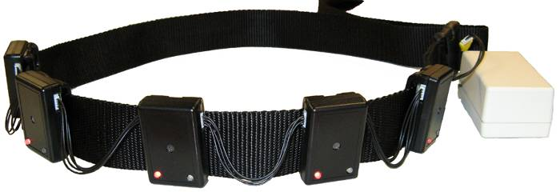

Figure 13. Haptic belt harness and tactor modules.

#### Tactor Module

The tactor module houses a controller which drives the vibration motor. An ATtiny88 Atmel microcontroller forms the core of the tactor module with a small design footprint and onboard oscillator. The pulse-width modulation (PWM) unit on the controller is used to change the amplitude of vibration (by varying the duty cycle) and also generate different vibrotactile patterns and rhythms. Six pins of the ATtiny88 were configured to read a DIP switch setting that allows automatic configuration of its data communication bus address upon cycling the power. This eliminates the need to reprogram all tactor modules for different applications/uses, thus providing plug-and-play functionality.

The circuit diagram of an individual tactor module is shown in Figure 14. A coin-type shaftless vibration motor, Precision Microdrives 312-101, forms the vibrator with a rotational speed of 150Hz and a nominal vibration of 0.9g. The motor is switched with a low-side NUD3105 MOSFET inductive load driver, which has internal back emf protection built into its circuitry. The use of a MOSFET allows for lower gate current (less than 1mA) and even less leakage current when compared to a BJT transistor. LEDs visible on the outside of the module are provided for debug purposes.



Figure 14. Tactor module schematic.

#### Main Controller

Since all control and data communication of the haptic belt flows through the main controller, it must handle several mechanisms of communication including UART, Wireless, and I**²**C data bus communication. The main controller must also have enough on-chip memory to store belt configurations and console debug menus. We chose a specific implementation of the popular Arduino Open Source platform, called Funnel I/O. The board is based on Atmel ATmega168 microcontroller, a fully functional 8-bit controller with 16KB of Flash memory. The Funnel I/O supports all of the capabilities of the ATmega168 with a 1:1 pad to pin ratio for input/output. The board already has a power switch, reset button, status LEDs, lithium ion charging circuitry through a miniUSB connector, battery connection, and headers prewired for a plug-and-play XBee wireless module. The PCB is fairly small in size, which meets our form factor requirements.

#### Wireless Module

We chose a self-encapsulated COTS wireless module with small form factor and an integrated chip antenna. Digi’s XBee ZNet module was selected given that the Funnel I/O controller board can integrate with it without any additional design and the supported mesh network is forward looking. The XBee is a plug-and-play ZigBee wireless protocol module that fully supports the IEEE 802.15.4 sensor mesh network standard, and offers data transfer rates of 250 kbps with a range of up to 133 feet indoors. Similarly, a self-encapsulated Bluetooth module RN-41 from Roving Networks, using the IEEE 802.15.1 protocol and with similar range to the Xbee, was selected for an alternate wireless interface because of its ubiquitousness and the module was easily modified to fit within the Funnel's Xbee port.

### 2.6.3.2 Software

#### Firmware

The architecture of the haptic belt’s real-time embedded firmware fulfills several purposes. It controls vibration amplitude, timing and location, from which vibrotactile spatio-temporal patterns can be created. Up to five rhythm patterns, four amplitudes and the last in-use mode configuration can be stored for later use. Additionally, the firmware controls all belt logic including inter-module communication including the PC-wireless link, on-chip memory, tactor modules on the data bus, and provides a basic console/terminal menu that allows direct interaction with the belt configuration through a serial communication link (wireless or RS-232).

With only limited memory space (16KB for the ATmega168 or 8KB for the ATtiny88), the firmware architecture had to be carefully engineered to provide the necessary functionality and ease of use while maintaining real-time performance. A simple command set structure similar to Hayes AT commands are used to minimize transmissions on the interconnect bus, and allows the 16 tactor modules to be sequentially switched on or off with a granularity of a few microseconds. The firmware was designed using the C language, and the open-source Arduino and Atmel’s AVR libraries. The firmware provides four primary user modes to create a new belt configuration, query the current configurations, test vibrotactile patterns, and activate “in-use” mode. There are several levels of configuration available that allow users the flexibility of creating different vibrotactile spatio-temporal patterns. The current configuration settings along with all programmed vibrotactile patterns are stored in non-volatile memory to maintain a readiness state and ease of use.

#### Graphical User Interface

The graphical controls, written using the C# language and .NET components, allow easy configuration of complex vibrotactile rhythm patterns using text inputs and drop-down menu selections (Figure 15). Users can also specify tactor module locations, and query the wireless haptic belt for its current configuration. The software also provides utilities for creating spatio-temporal patterns using specified tactor modules and rhythms.

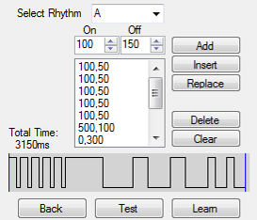

Figure 15. Graphical interface controls for vibrotactile rhythms.

While the details of the hardware design of the haptic belt are shown here, the usability aspect of it is not discussed here. Details of the application of the haptic belt as a part of Social Interaction Assistant will be provided in Chapter XXX, where the problem of delivering Proxemics information as a non-verbal cue is discussed from the sensing and the delivery perspective.

# 2.7 Summary:

In this chapter a detailed analysis of the important social cues for people who are blind and visually impaired were analyzed through an online survey and the two most important needs of feedback on one’s own body mannerism and the importance of facial expressions in social interpersonal communication were established.

Following the discussion of the important social needs, we have introduced a novel assistive technology framework that is capable of sensing and delivering some of the important non-verbal visual cues to people who are blind or visually impaired. From the perspective of an assistive technology, we only introduced the system side of the development. More on the usability will be discussed in the successive chapters.

1. In order to understand the assistive technology requirements of people who are blind, we conducted two focus group studies (one in Tempe, Arizona USA - 9 participants, and another in Tucson, Arizona USA - 11 participants) which included:

   1. students and adult professionals who are blind,

   2. parents of individuals who are blind

   3. professionals who work in the area of blindness and visual impairments.

   There was unanimous agreement among participants that a technology that would help people with visual impairment to recognize people or hear them described would signiﬁcantly enhance their social life.
2. To quote some candidates opinion about face recognition technology in a social setting:

   • “It would be nice to walk into a room and immediately get to know who are all in front of me before they start a conversation”.

   One young man said, “It would be great to walk into a bar and identify beautiful women”.